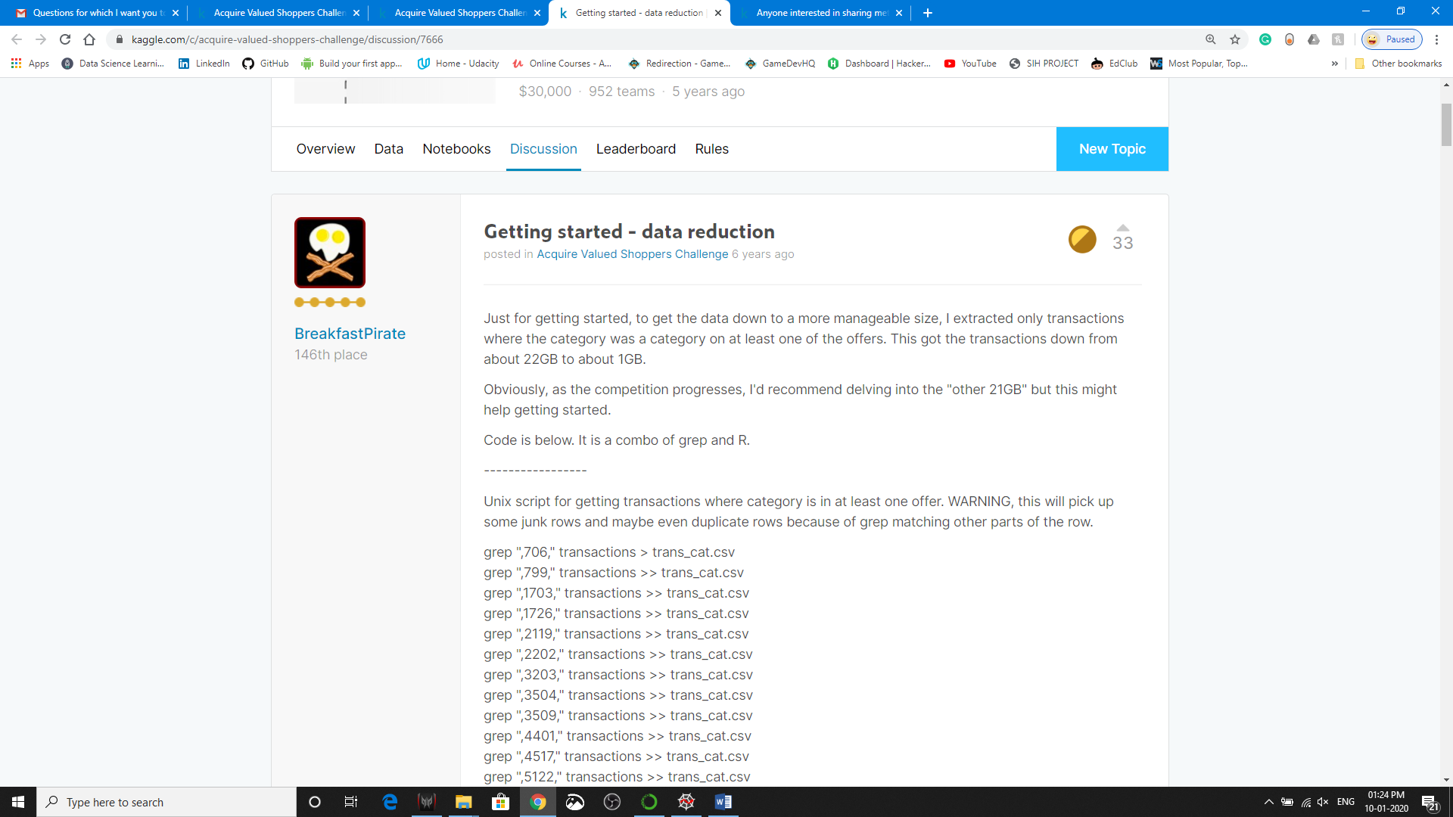

Transaction file summary statistics:

349655789 records

total purchasequantity 584540514

total purchaseamount 1568488398

